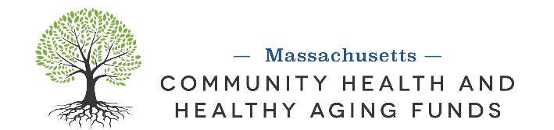

Work Plan Template
Activities  Minimum 3 major activities that will contribute to the project goal | Timeframe  Which fiscal year and quarter this activity will occur. | Community Engagement  Highlight how the activity would engage the target/priority community.  (1) Who influences?  (2) Who makes decisions?  (3) Where does this activity fall in the public participation spectrum? | Anticipated Outcomes  List changes anticipated from the activity  Identify the Policy, System and/or Environmental (PSE) change approach for each key project outcome
Ex: Quarterly steering committee meetings with lived experience community members and local coalitions | Ex: FY27 Q1, FY 28 Q1, FY29 Q1, FY 30 Q1, FY 31 Q1 | Ex: Targeted communities are involved in designing and providing feedback to improve the process | Ex: Increase community involvement and diversity

