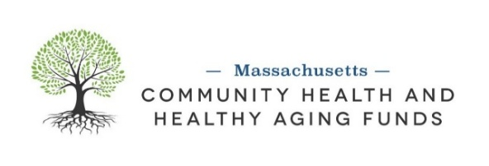
Advisory Committee Membership Recruitment

Background
In January 2017, the Massachusetts Department of Public Health (MDPH) completed a landmark revision of the Determination of Need (DoN) regulation which led to the creation of the Massachusetts Community Health and Healthy Aging Funds (The Funds). Resources for the Community Health and Healthy Aging Funds are from hospitals, long-term care facilities, and other healthcare entities that are required to contribute through the MDPH’s Determination of Need Program. Click here for additional information on the Determination of Need program.

Purpose
The Funds are an opportunity to reduce health inequities in communities across Massachusetts by addressing their root causes and the social determinants of health, specifically institutional and structural racism, through both grantmaking and capacity building.
The Funds are guided by the following principles:
- The Social Determinants of Health (SDoH) account for significant variation in health outcomes. http://www.mahealthfunds.org/what-we-fund/
- Policies, systems, and social/physical environments are historically based on structural and institutional racism and other forms of oppression.
- Structural and institutional racism and other forms of oppression need to be understood and disrupted to eliminate inequities in population health outcomes and the social determinants of health (SDoH).

The Health EquiTREE below illustrates the relationship between health outcomes and the root causes of health inequities. It helps us envision how systems impact outcomes of individuals and groups.
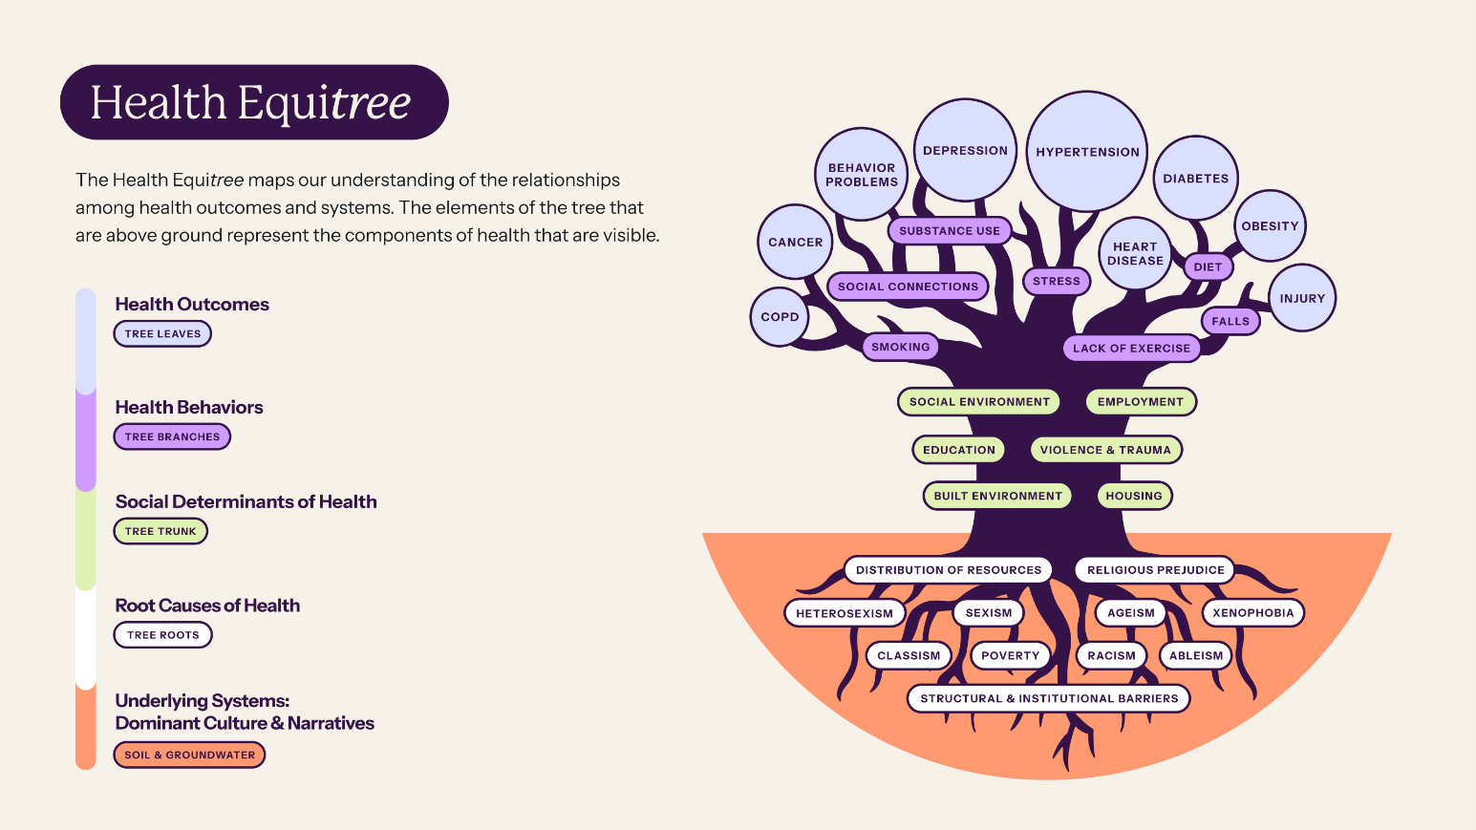

The Community Health funding streams, which include Policy, Systems, and Environmental (PSE) Change and Community Health Improvement Planning (CHIP) Processes, envision all Massachusetts residents having an equitable opportunity to achieve the highest possible quality of life. The vision for the Healthy Aging funding stream is to contribute to equitable systems across sectors affecting community-level physical environments and social and economic conditions, ultimately leading to a better quality of life and health outcomes for older adults as they age in Massachusetts.

To realize these visions, the Funds will invest in community-centered approaches that intentionally address the root causes of inequitable health outcomes.

Role of the Funds Advisory Committee
The primary role of the Advisory Committee is to provide recommendations for the operations of the MA Community Health & Healthy Aging Funds, specifically the practical application of values and principles. Advisory Committee members are asked to leverage their expertise, lived experience, and their community’s perspectives to inform the creation of grantmaking and processes that (1) support and reflect communities and (2) ultimately help to ensure all Massachusetts residents have an equitable opportunity to achieve the highest possible quality of life.

The key responsibilities of Advisory Committee members include to:
- Question if and how the Funds are dismantling existing systems, including structural racism and other root causes of inequities, and building new infrastructures to produce more equitable outcomes generally, as well as in grant distribution processes
- Represent- Serve as advocates in institutions and communities to uphold the vision and mission of the Funds
- Hold Accountable state government and other stakeholders to the stated vision and goals of the Funds
- Assess by reviewing analyses of results and data from awardees to inform future iterations of funding cycles, as well as to assess the broader impact of the Funds
- Engage and Connect with and between state agencies and community members, as well as potential stakeholders of the Funds

At a minimum, Committee members are asked to:
- Uphold DPH’s commitment to advancing racial and health equity, addressing social determinants of health, and the MDPH’s priorities
- Review pre-meeting materials and reports as disseminated by MDPH, EOEA, and HRiA
- Attend meetings and actively engage in the development of recommendations
- Leverage personal expertise and networks to inform Committee activities

The committee is not responsible for developing any funding opportunity materials (e.g. RFPs), reviewing applications or making funding decisions. HRiA, as the Fiscal Agent for the Funds, is responsible for these activities under the direction of MDPH. However, Committee members can choose to participate on the Review Committee, which includes a Conflict-of-Interest process and policy.

Membership with the Funds’ Advisory Committee will be jointly determined by MDPH, EOEA, and HRiA. Within this Advisory Committee, MDPH seeks representation from:
- Massachusetts residents and regional stakeholders who can provide recommendations based on lived experience or lived experience of oppression knowledge and influence on effective strategies and initiatives that support healthy aging and community health efforts and/or expertise in at least one of the six DoN Health Priorities. Lived experience is defined as someone who has lived (or is currently living) with the issues the community is focusing on and who may have insight to offer about the system as it is experienced by consumers (i.e. substance use disorder, homelessness, etc.). Lived experience of oppression is the sum of an individual’s past events and personal history with navigating systems of power through their marginalized/oppressed identities or backgrounds. Lived experience is not defined ONLY as one’s firsthand experiences – a person’s circumstances must have been filtered through encounters where their stability or well-being was negatively impacted by systemic oppression.
- Committee members must be a minimum of 18 years old.
- Those who can apply a healthy aging lens to a community-based and social determinant of health approach.
- Those who can apply a community health lens to a community-based and social determinant of health approach.
- Those who can apply a racial and health equity lens to a community-based and social determinant of health approach.
- MA-based professional associations whose work directly impacts one or more of the six DoN Health Priorities.

Advisory Committee Terms/Length of Service
Committee members will be asked to serve a term that spans up to 4 years, which covers roughly two grantmaking cycles, with the possibility of renewal. Terms will be staggered to ensure the effective transfer of knowledge. If a member leaves the Committee, nominations for a new member will be made during regular recruitment and onboarding cycles throughout any given year.

How to Apply
Advisory Committee members are accepted on a rolling basis. Interested individuals should submit a letter of interest, a resume, and a letter of recommendation from their employer (if they are currently employed) to machhafunds@hria.org. Please allow time for your application to be reviewed. For more information and updates contact please contact Alberte Altine-Gibson at aaltine-gibson@hria.org.

2https://newdiscourses.com/tftw-lived-experience/
https://www.communitycommons.org/collections/1-Getting-Started-Engaging-People-with-Lived-Experience

